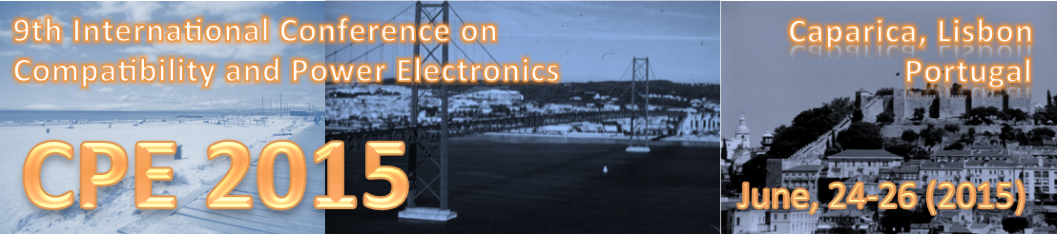

9th International Conference on Compatibility and Power Electronics (CPE2015)
24-26 June 2015
Lisbon, Portugal

Special Session:
(Name of the Special Session)

Special Session Organizers (names and contact emails):

Name (email , affiliation)
Name (email , affiliation)
Name (email , affiliation)

Technical Outline of the Session and Topics (100-200 words):

Scope:

Contributions to the session address but are not limited to:

Potential Contributing Authors (names and emails):

Name (email , affiliation)
Name (email , affiliation)
Name (email , affiliation)

Potential Reviewers (names and emails):

Name (email , affiliation)
Name (email , affiliation)
Name (email , affiliation)

