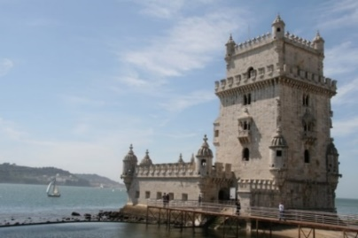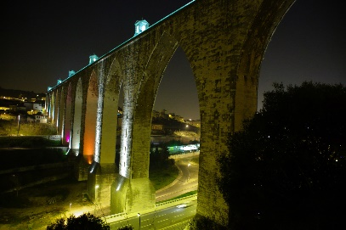
14th International Conference on
Information Technology Based Higher Education and Training
ITHET 2015
11-13 June 2015, Caparica, Lisbon, PORTUGAL

Special Session on

{include the title of the special session}

Special Session Organizers (names and contact emails):

Technical Outline of the Session and Topics (100-200 words):

Potential Contributing Authors (names and emails):

Potential Reviewers (names and emails):

