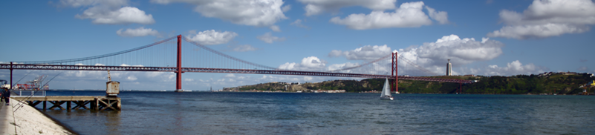
HSI 2014
7th International Conference
on Human System Interaction
16-18 June, 2014 Hotel Costa da Caparica, Lisbon, Portugal

7th International Conference on Human System Interaction (HSI’2014)
16-18 June 2014
Hotel Costa da Caparica, Lisbon, Portugal

Special Session on

{include the title of the special session}

Special Session Organizers (names and contact emails):

Technical Outline of the Session and Topics (100-200 words):

Potential Contributing Authors (names and emails):

Potential Reviewers (names and emails):

